Testing Report

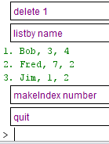Made sure to test 1 0 and many whenever applicable often including first middle and last during those tests. To test final product I manually tried each method. The results can be seen below